
FEST Research Group
Final Year Project Proposal
Project Title: | KIDSTUBE Pakistan
Degree Program/ Title: | Computer Science

Project Supervisor: |  | Signature:
Project co-supervisor: |  | Signature:

Student Name & Registration No: | Email & Phone Number: | Student Signature:
Misbah Aslam Sheikh  28272 | misbah.asl96@gmail.com  03009210111
Muneeb Ahmed  28863 | muneebahmed39@yahoo.com  03022220672
Anosha Ilyas  32356 | saadilyas49@gmail.com  03312087744

List of Abbreviations and Acronyms

1. DB - Database
2. FEST - Faculty of engineering science of technology
3. ERD - Entity relationship diagram
4. HoD - Head of department
5. AS- Android Studio
6. VS-Visual Studio
7. MS SQL- Microsoft SQL Server 2014
8. UI – User Interface
9. GUI – Graphical User Interface

Table of Contents

Description Page #

Section – 1 1
1.1 Project Identification 1
Section – 2 5
2.1 Background 6
2.2 Outcomes and Benefits 7
2.3 Objectives 8
2.4 Research Approach 9
2.5 Risk Analysis 10
Section – 3 11
3.1 Resources & Other Requirements 11
Annexure–A: Project Schedule / Milestone Chart 13
Annexure–B: Proposed Budget 14
Annexure–C: Business Canvas Model 15
Bibliography 16

Final Year Project Proposal

Section – 1

1.1 Project Identification
Project Title:
Kidstube Pakistan

Group Leader (GL):
1. | Name: |  | Misbah Aslam Sheikh
 | Reg #: |  | 28272
 | CGPA: |  | 2.78
 | Mobile # : |  | 03009210111 |  | Email: |  |  |  | misbah.asl96@gmail.com
 | Signature:
Group Members (GM’s):
2. | Name: |  | Anusha Ilyas
 | Reg #: |  | 32356
 | CGPA: |  | 2.96
 | Mobile # : |  | 03312087744 |  |  |  |  | Email: |  | saadilyas4@gmail.com
 | Signature:
3. | Name: |  | Muneeb Ahmed
 | Reg #: |  | 28863
 | CGPA: |  | 2.6
 | Mobile # : |  | 03022220672 |  |  |  |  | Email: |  | Muneebahmed39@yahoo.com
 | Signature:
What technology is core to your product? (Please mark ☑ where applicable)
[ ] 3D/4D Printing |  | [ ] Augmented Reality / Virtual Reality
[ ] Big Data, Artificial Intelligence |  | [ ] Blockchain
[ ] Cloud |  | [ ] Neurotech
[ ] Robotics |  | [ ] Shared economy
[ ] The Internet of Things |  | [ ] Wearables, Implantables
[✓] Others (specify): | Mobile Application & Development

What is the target market(s) for the products? (Please mark ☑ where applicable)
[ ] Automotive, aviation, marine |  | [ ] Business, marketing, finance
[ ] Defence, security, safety |  | [✓] Education and training and Entertainment
[ ] Environment, water management |  | [ ] Entertainment, tourism, sport/recreation
[ ] Food, livestock, agribusiness |  | [ ] Healthcare
[ ] Infrastructure, housing & transport |  | [ ] Mining equipment technology & services
[ ] Oil, gas, energy |  | [ ] Textiles, clothing, footwear
[ ] Others (specify):

Other Organizations Involved in the Project: (Please identify all affiliated organizations collaborating in the project, and describe their role/contribution to the project.)
Academic Organizations:
# |  | Organization Name |  |  |  |  | Role / Contribution
 |  | Iqra University |  |  |  |  | Hosting the project and group
Industrial Organizations:
# |  | Organization Name |  |  |  | Role / Contribution
Funding Organizations:
# |  | Organization Name |  |  |  |  | Role / Contribution
Key Words: (Please provide a maximum of 5 key words that describe the project)
To indulge the child’s interest toward an application that promote ethical entertainment platform according to our religion

Research and Development Theme: (please identify the Research Theme.)
Previous application for child’s entertainment and learning

Project Status: (Please mark ☑)
[ ] New [ ] Modification to previous Project
[ ] Extension of existing project

Project Duration: |  |  |  | 12 Months
Proposed Budget: |  |  |  | 976000 PKR
The Problem:
In today’s world everyone is using smartphones and apps even small children’s uses apps like
YouTube to watch funny videos and cartoons. YouTube has created a special app for kids known as YouTube Kids where there is content for small kids like cartoons and videos, and all the necessary functions that parents need in today’s worldly technology in order control the child’s activity and routine using YouTube
Following are some of the well-known (identify the best known if possible) existing solutions to this problem. Their known strengths and weaknesses are also provided.
YouTube has launched their own application for kids named as YouTube for kids in order to fulfill parent’s requirements for the bringing up of their child. It has provided every of the feature to counsel the child in very good manner, but has not restricted certain videos that is unethical according to our religion. And also doesn’t contain any religious video as it is for every international and national user.
Our solution will address the following weaknesses of above mentioned solutions.
Those cartoon videos, entertainment, knowledge videos will be updated that will be righteous for a child according to religious perspective and other necessary and valid stuff too.
We will use the following techniques to achieve improvements mentioned above.
We will research through web or addressing parents that what they want for their child in certain application so they will trust on the application that their child is using an application that is safe in every aspects.
Our project is totally software based so we will be using these technologies which are going to fulfill the meets and requirements of our projects such as:
AS- Android Studio
VS- Visual Studio
DB- Database
MS SQL- Microsoft SQL Server 2014

Synopsis:
In today’s world everyone is using smartphones and apps even small children’s uses apps like YouTube to watch funny videos and cartoons. YouTube has created a special app for kids known as YouTube Kids where there is content for small kids like cartoons and videos, and all the necessary functions that parents need in today’s worldly technology in order control the child’s activity and routine using YouTube. Our project will be the replica of the existing app but some of functions might get changed basis on Pakistani culture only.
Our prime objective is to create a platform where children can enjoy videos which are relevant and good for them and which will also help in their right growth since there is religious and ethical content as well in assistance with parents.

Section – 2

2.1 Background
Scope of the Project:
The scope of this project defines the fulfillments of parents need and to satisfy them with such a thing on which they can blindly trust and let their children depend upon it for such activities than YouTube without having any advertisement, or any other act that parents won’t like for their child.
Our goal is to provide or made the replica of the product with certain amendments that’s requires
Time limit of watching any video
No comments
No user is allowed to sign up or upload the video(decision can be changed)
Only the owner has the right to upload and delete the content by the reviews of the people on app store
All types of youngest interest will be tried to update in the application based on our culture
Cartooned characters, educational videos we will enforce Islamic videos too that includes the recitation of Qaida to Quran Paak including duas and naat
Time limit will be applied manually by the user(parent)
No promotion of irrelevant advertisement's on the app

Literature Review:
The system will be explained in its context to show how the system interacts with other systems and introduce the basic functionality of it. It will also describe the type of stakeholders that will use the system and the functionality is available for each one of them. The system we decided to made come out because of the following drawbacks. YouTube is public, so, anyone can see the videos that you post, anyone can post a video, there could be copyright infringement issues, and there could be issues of privacy invasion. If the children can access YouTube , you probably need a parental block, some videos can sometimes be inappropriate without warning, there is violence on some of the videos, there are explicit videos and the teens are recording violence to post on. For particular children need YouTube has created special app for the youngest fans that offers particular dilemma according to respective needs but this also has certain things that is not preferred by our country policy.
Develop an app considering the needs of a child and preferment of the parent according to our culture and environment needs without having any advertisement of adds in the app.

Current State of the Art:
The mobile app market is growing faster than a beanstalk. The industry is huge and growing daily, and there is no end in sight. Expectedly, the mobile developer population has boomed, and the number of mobile apps in the market has hit new heights. The revenue generated by Fthe global mobile app industry has skyrocketed. Hybrid monetization models, such as in-app ads and in-app purchases, are quickly gaining popularity in the business world.

Trends:
Accelerating Mobile Pages
Cloud driven mobile apps
Enterprise& micro apps
Focus on security

Challenges:
Building application with simple, understandable & good UI
Creating Application which is Get Noticed.
Give Attention to User Comment and Feedback
Retention Rate

Motivation and Need:
Currently there are many mobile applications for the kids but they all have many things which are not appropriate for kids like irrelevant advertisement’s & promotions, wrong content which may affect child’s mental health that’s why we are developing this application which will have the only content which is good or right for child’s right growth. It will also have some additional features set.
This type of application is very much needed in today’s world because parents can’t monitor what their child is watching every time. Through this application parents will have the satisfaction that their child is not watching any wrong or inappropriate video because they can set the playlist on their own and child cannot watch anything else without parents permission.

2.2 Outcomes and Benefits
Expected Outcomes:
Complete documentation
Deployed mobile application with database of users and videos

Key Benefits and Beneficiaries:
Beneficiaries:
Users
Enterprises
Developers
Advertisers
Benefits:
Parents don’t need to supervise their children activity when they are watching videos
It will generate revenue for the owner of app

Technology Transfer/Diffusion Approach:
This application will be freely available on play store for downloading. It will have a very simple design and UI so that the user will have no problem using the application. We will let the customers know about this application through promotions and advertisements on other applications and social media platforms.

2.3 Objectives
Research Objectives:
To come up with the child’s basic requirements for their basic bringing up through parent’s views.

Academic Objectives:
To implement the particular options in academic point of view as it is the basic need of the society

Other Objectives:
To build an application that fulfillments of parents need and to satisfy them with such a thing on which they can blindly trust and let their children depend upon it for such activities than YouTube without having any advertisement, or any other act that parents won’t like for their child.

2.4 Research Approach
Development / Research Methodology:
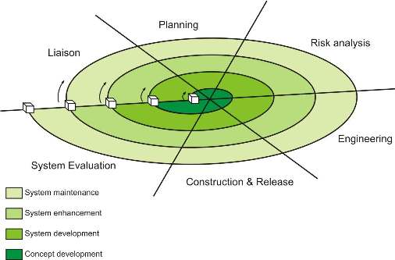
Spiral Model

Software process model Spiral model is best process model for Online Railway Reservation System. Spiral model combines the idea of iterative development with the systematic, controlled aspects of like waterfall model. Very high emphasis on risk analysis. It allows for increment release of the product or increment refinement through each iteration around the Spiral. Changing requirements van be accommodated. Allows for extensive use of prototype. Requirements can be captured more accurately. Development can be divided into smaller parts and riskier part can be developed earlier which help better risk management.

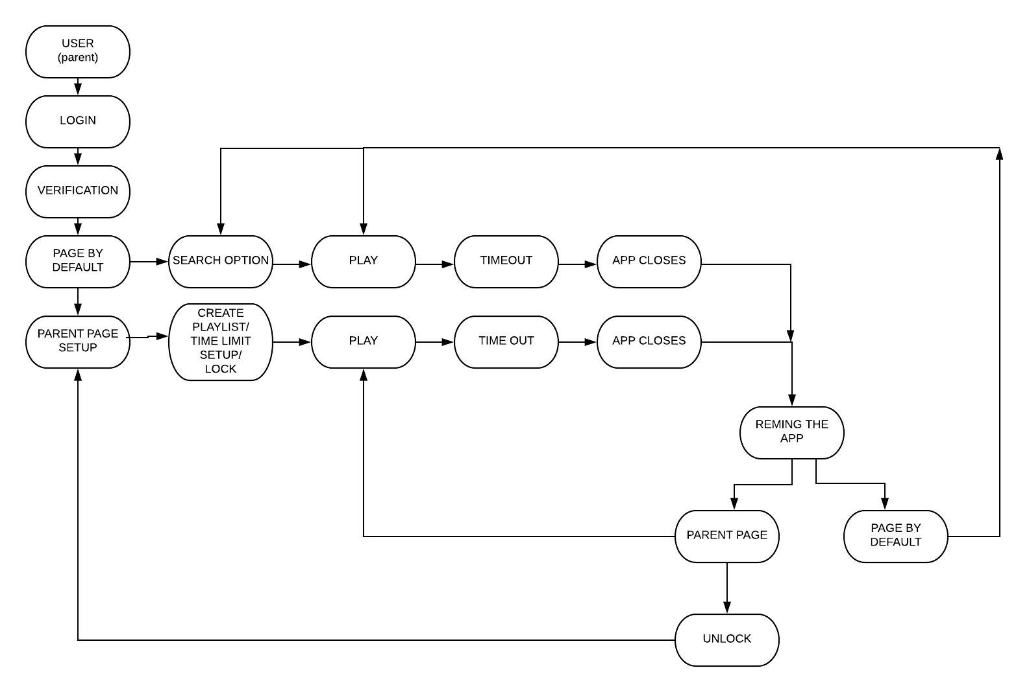

Key Milestones and Deliverables:
S. No. | Elapsed time since start of the project | Milestone | Deliverable
1. | Week 01 – 04 | Idea approval | Presentation
2. | Week 05 – 08 | Idea approval | Presentation
3. | Week 09 – 12 | Functional and nonfunctional | Approved
4. | Week 13 – 16 | ERD | Approved
5. | Week 17 – 20 | Prototyping | Approved
6. | Week 25 – 24 | Front GUI design
7. | Week 25 – 28 | Backhand coding
8. | Week 29 – 32 | Database
9. | Week 37 – 36 | Testing
10. | Week 37 – 40 | Final

2.5 Risk Analysis
Risk | Likelihood  (Low, Med, High) | Impact | Mitigation
Sign up option | medium | Will log in anonymously | Bu a user will be having every functions to use after not being sign up.
Application crash | Low | Sometime mobile performance can affect the app | To rectify this we use loe memory RAM to run this app

Section – 3

3.1 Resources & Other Requirements
Project Team:
Title / Position | Number
Team Leads | 01
Researchers / Developers | 01
Researcher / Development Assistants | 03
Support Staff | 05
Contract Staff (please specify) | -
Others (please specify) | Software promotion and hardware liabilities
Add more rows if required | -
Team Structure:
Title/Position  (of each member) | Role/Key Responsibilities | Minimum Qualification Required | Expertise / Background Required | Minimum Experience Required (years)
Project Manager | Team Leader, Documentation | BsCs | Project Documentation | 01
Developer | Android Developer | BsCs | MAD | 1 year or more
Developer | Android Developer and database designing | BsCs | MAD & DBMS | 1 year or more

Remarks:

1. Name & Signature of Supervisor:

2. Name & Signature of Co-Supervisor:

3. Name & Signatures of FYP Coordinator:

Annexure–A: Project Schedule / Milestone Chart

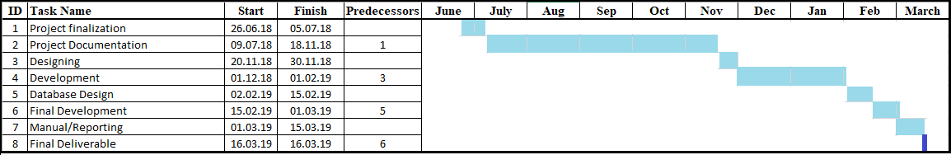

Annexure–B: Proposed Budget

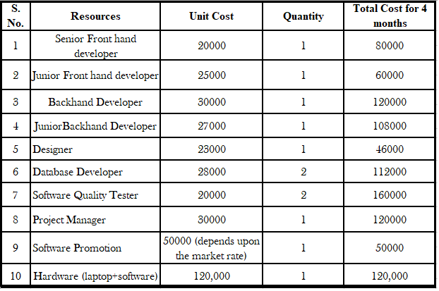

Annexure–C: Business Canvas Model

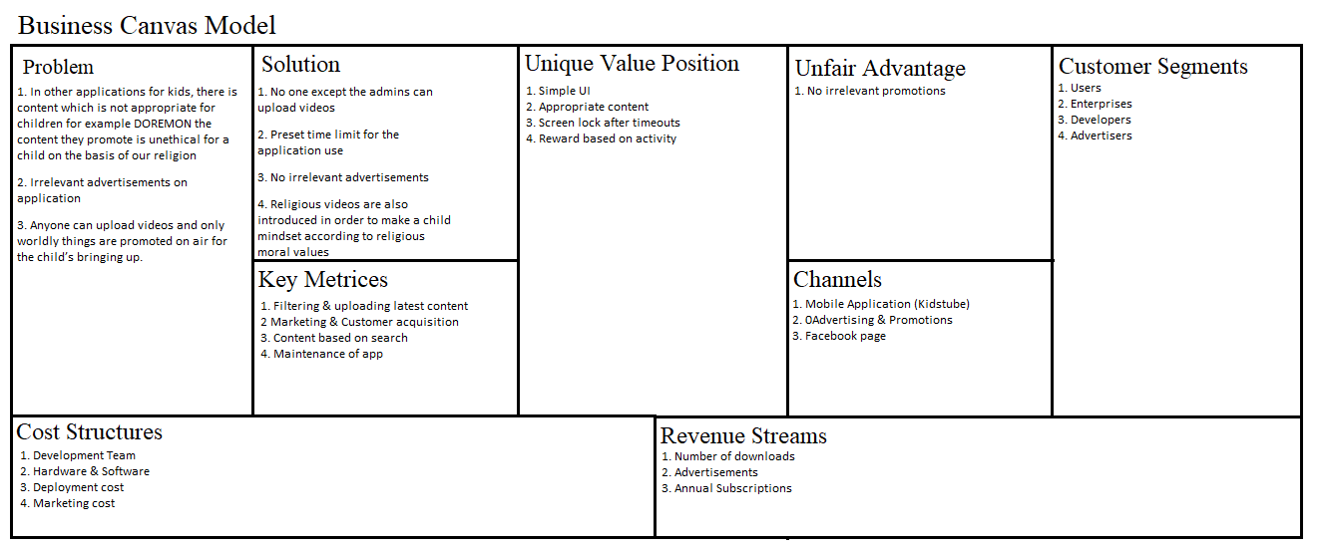

Bibliography
https://strikesocial.com/blog/youtube-ad-specifications
https://www.youtube.com/watch?v=A-ZfIupE2Ak
https://en.wikipedia.org/wiki/YouTube_Kids
https://developer.android.com/studio
https://www.mysql.com
https://en.wikipedia.org/wiki/Mobile_app_development
https://rubygarage.org/services/mobile-app-development
https://buildfire.com/become-mobile-app-developer/
https://www.youtube.com/

